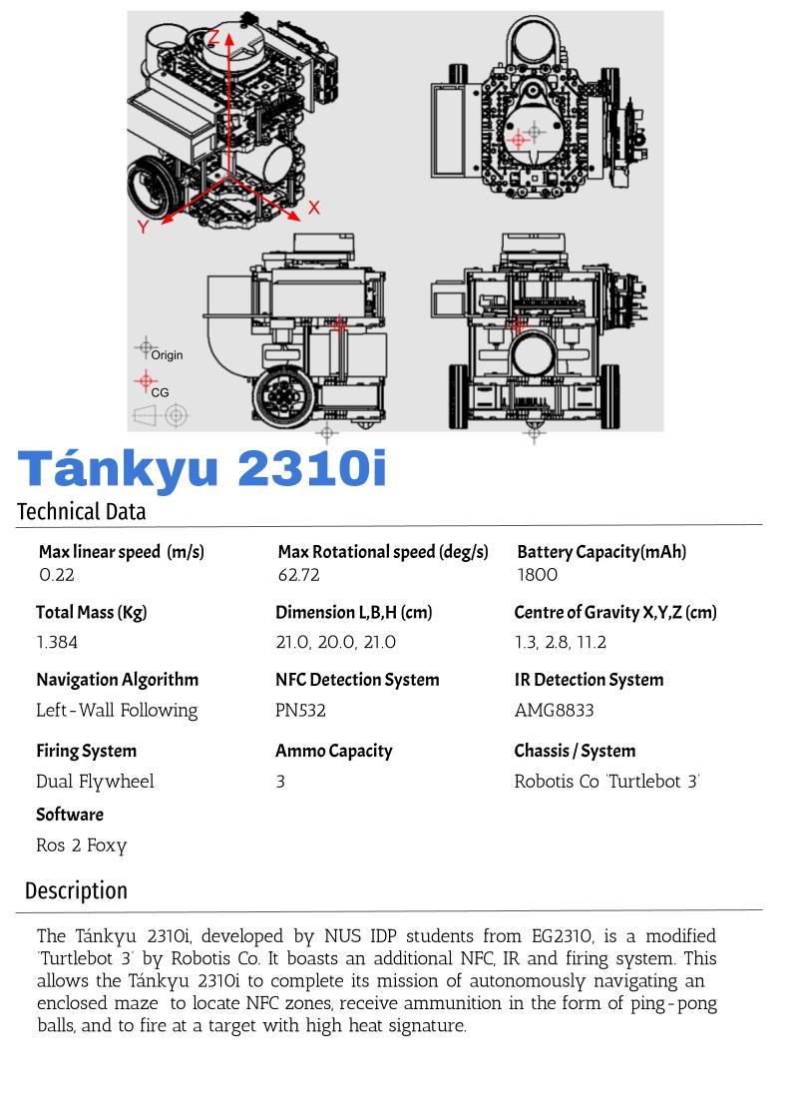

Hardware Guide

|  | S/N | Description | Qty |
| --- | --- | --- | --- |
| 01. | Lidar | 01 |
| 02. | Li-Po Battery | 01 |
| 03. | Switch | 01 |
| 04. | OpenCR1.0 | 01 |
| 05. | Custom Acrylic Waffle Plate | 01 |
| 06. | SG90 Servo Motor | 01 |
| 07. | Dynamixel Motor | 02 |
| 08. | PN532 NFC Reader | 01 |
| 09. | PVC Tube Magazine | 01 |
| 10. | Flywheel Motor | 02 |
| 11. | AMG8833 IR Camera | 01 |
| 12. | Raspberry Pi w/ PCB Hat | 01 |
| 13. | Wiring Harness Set (not illustrated)  6 pin to 6 pin …..……… QTY: 01  4 pin to 4 pin ………….. QTY: 01  2 pin to 2 pin ………….. QTY: 03  3 pin to 3pin …………... QTY: 01  T-Plug M -F .…………... QTY: 01  USB to Micro USB ….... QTY: 02  TTL cable ……………... QTY: 02 | 01 |

Software Block Diagram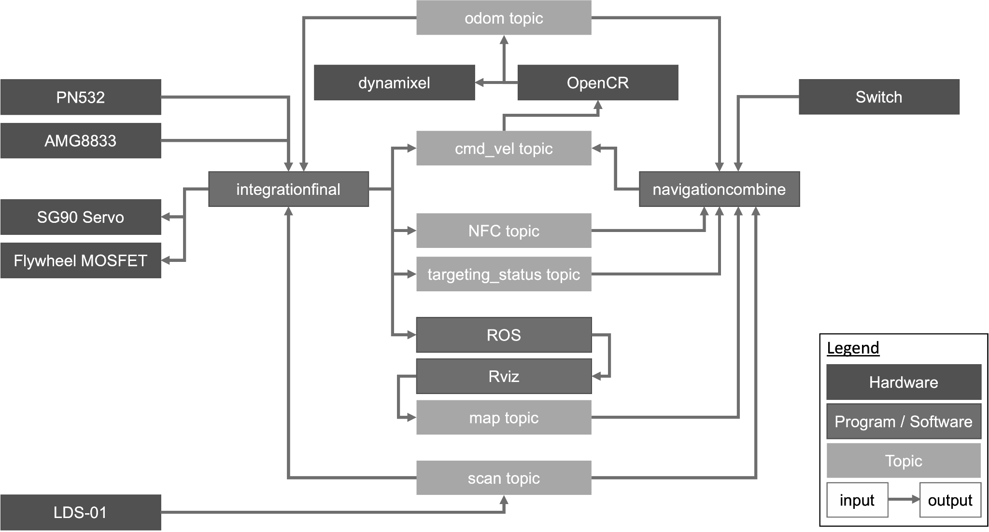

Loading Method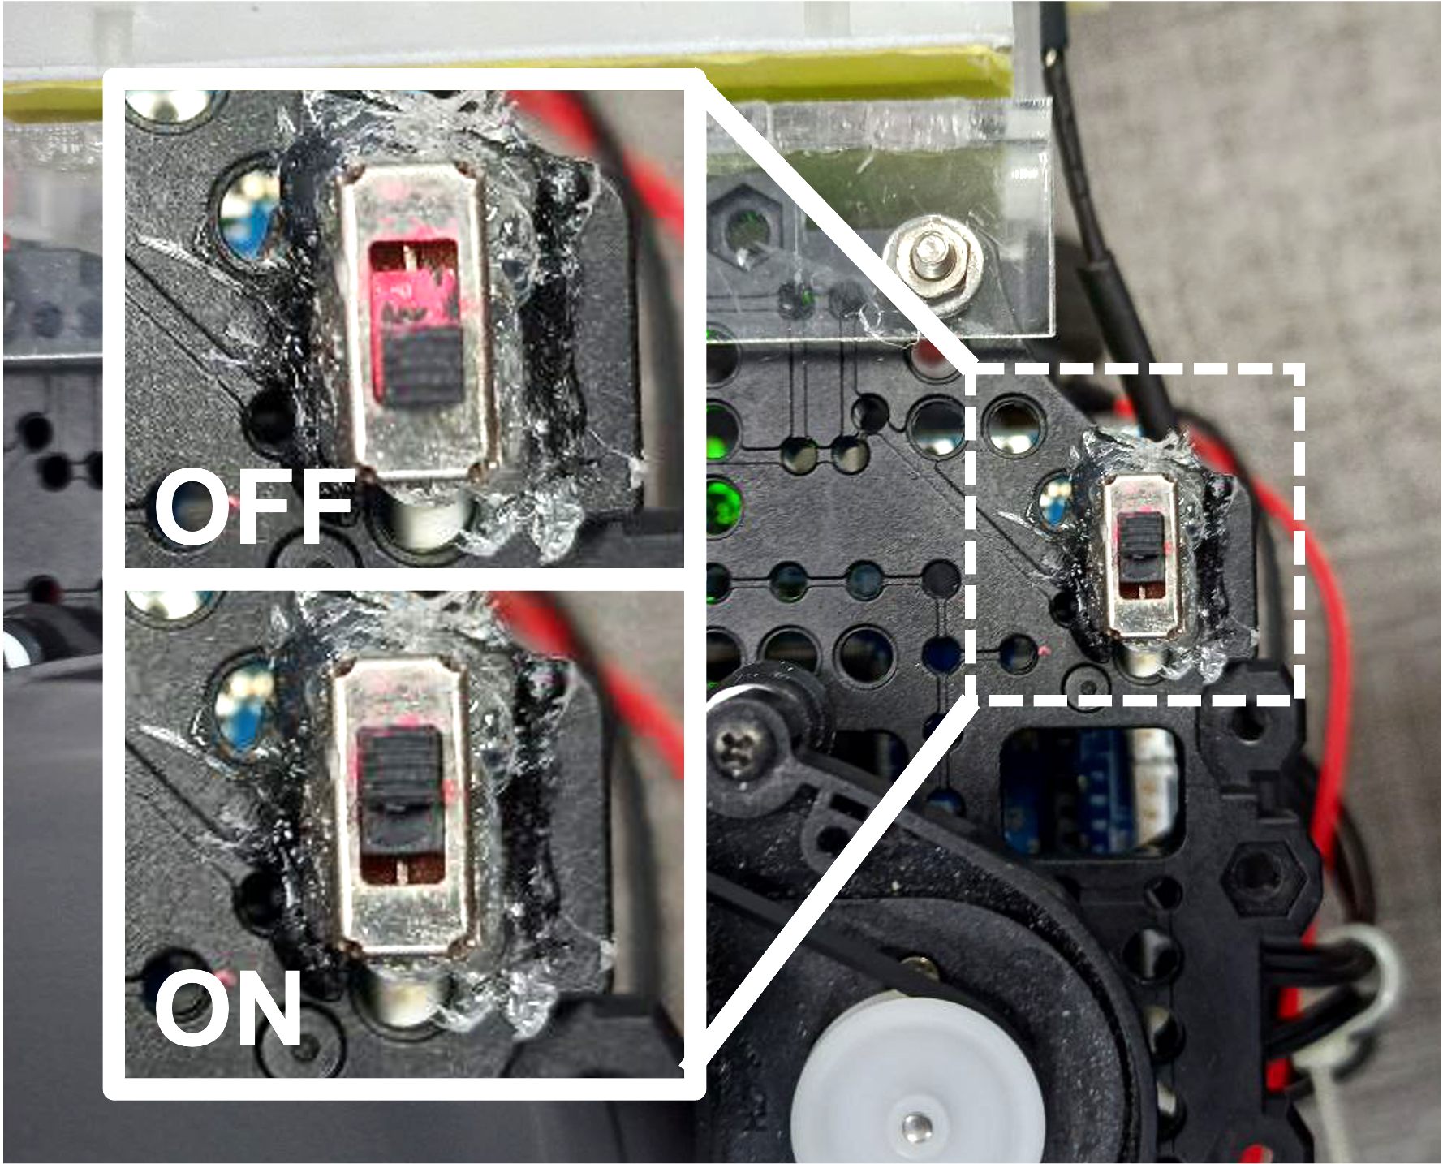

1. When Tánkyu 2310i halts in the loading zone, insert QTY: 03 ping-pong balls into the tube magazine.
2. Move the switch located at the front left corner to the ON position (refer to Figure 1.1).
3. Tánkyu 2310i will resume the mission.

*Figure 1.1 Switch Off and On positions (Right)*

| **Acceptable Deferred Defects Log** | | | | |
| --- | --- | --- | --- | --- |
| *S/N* | *Defect Description* | *Risk Classification Level\** | | |
| *Low* | *Med* | *High* |
| 01. | Flywheel tires are worn. Flywheel is able to launch payload at acceptable velocities. | X |  |  |
| 02. | Bottom left of the buck converter near the “IN-” pin is slightly charred. Buck converter works fine. | X |  |  |
| 03. | Servo arm is not long enough, temporarily augmented with a paper clip to extend the range. | X |  |  |
| 04. | GPIO21 noted to be faulty. Does not affect system performance. Future connections are advised to be made to other unused GPIO pins such as GPIO12, GPIO16 or GPIO20. | X |  |  |
| 05. | PVC pipe elbow connector is not smooth and may cause the last ping pong ball to get stuck. Duct tape can be added to smoothen the bend to ensure that the last ping pong ball can roll to the flywheel. |  | X |  |
| 06. | Motor Driver Hat PCB has grounding issues. See parts replacement & maintenance log S/N 06 for temporary rectification. |  |  | X |

| Risk Classification Level* | |
| --- | --- |
| Low: | The Tánkyu 2310i will still be able to complete the entire mission as per normal. |
| Med: | The Tánkyu 2310i may operate at reduced performance but will still be able to complete the entire mission. |
| High: | The Tánkyu 2310i requires close supervision during the mission, if problems arise, immediately retire the Tánkyu 2310i for maintenance before starting another mission. |

| **Factory Acceptance Test** | | | | |
| --- | --- | --- | --- | --- |
| *S/N* | *Test Description* | *How to Trigger the Test* | *Expected Result* | **✔** |
| General | | | | |
| 1.1 | Shake test | Remove the battery and then shake the Tánkyu 2310i. | No components should be detached or loose. |  |
| 1.2 | Is the Tánkyu 2310i able to power on? | With a charged battery attached, move the switch on the right side of the tánkyu 2310i to the ‘On’ position. | - 6 beeps heard  - Constant red LED on R-Pi and buck converter  - LIDAR starts to spin |  |
| 1.3 | Can the Tánkyu 2310i complete the bring up? | Run *rosbu* with Tánkyu 2310i placed on level ground. | Last row of the terminal output reads ‘Run!’ |  |
| Navigation System | | | | |
| 2.1 | Is the LIDAR working properly? | Run *rteleop* and *rslam* on the laptop and manually navigate to allow Tánkyu 2310i to map area. | Live slam map is being recorded by the R-Pi. |  |
| NFC Detection System | | | | |
| 3.1 | Can the NFC sensor detect the loading bay? | Run *rteleop* on laptop and *nfc_test.py* on the R-Pi, then drive over an NFC tag. | Terminal reads  “NFC Detected”. |  |
| IR Detection System | | | | |
| 4.1 | Can the IR sensor detect the “Hot target”? | Run *ir_publisher.py* on R-Pi. Run *rteleop* and *ir_test.py* on the laptop, then drive to point IR towards “Hot target”. | Live feed of the temperature array identifies the “Hot target” in red and the terminal reads out the highest temperature detected. |  |
| Firing System | | | | |
| 5.1 | Can the servo open on command? | Run *servo_test.py* on the R-Pi. | Servo actuates and rotates to the input angle and remains in that position. |  |
| 5.2 | Can the flywheel motor run on command? | Run *motor_test.py* on the R-Pi and input 1 to start motor and 0 to stop. | Both Motors turn on upon ‘1’, and off upon ‘0’.  Left motor spins anti-clockwise while the right motor spins clockwise when viewed from the top. |  |

| **Parts Replacement and Maintenance Log** | | | | |
| --- | --- | --- | --- | --- |
| *S/N* | *Date Reported* | *Description of Replaced Part* | *Part Number / Name /*  *Reference* | *Remarks* |
| 01. | 18/01/22 | Swapped out laser sensor on Tánkyu 2310i. | LDS-01 laser sensor | Hardware faulty. |
| 02. | 20/01/22 | Swapped out spare R-Pi. | R-Pi 3B+ | Hardware faulty. |
| 03. | 05/04/22 | Replaced R-Pi with spare R-Pi. | R-Pi 3B+ | I2c Channel unresponsive. |
| 04. | 07/04/22 | Full teardown and rebuild for cable management and to incorporate PCB. | - | Wires cut to length and wiring harnesses implemented to best ability. |
| 05. | 08/04/22 | Replaced SG90 servo with spare servo. | Micro servo 9g SG90 | Servo unresponsive. |
| 06. | 08/04/22 | Replaced PCB with breadboard circuit. Breadboard placed in battery holder so battery will be mounted separately and secured using zip ties temporarily. | Motor Driver Hat PCB,  Mini breadboard | Refer to Acceptable Defect Log S/N 05 for fault corrected by replacement. |

|  |  |
| --- | --- |
| *Refer to our [Assembly Manual](https://github.com/hahaha2002/r2auto_nav/blob/main/Documentations/02%20-%20Assembly%20Manual%2C%20Ta%CC%81nkyu%202310i.pdf) for the full assembly instructions. | *Refer to our [GitHub Repository](https://github.com/hahaha2002/r2auto_nav) for full software setup and calibration methods. |